**Question -1**

Explain VCS and its type

**Answer: -**

VCS stands for Version control system, it records all the changes made to a file so s specific version may be called later it needed.

version control systems are broken down into two main categories, centralized and decentralized (also known as distributed).

**Centralized Version controlled system: -**

Centralized version control systems are based on the idea that there is a single “central” copy of your project somewhere (probably on a server), and programmers will “commit” their changes to this central copy. “Committing” a change simply means recording the change in the central system.

**Decentralized Version controlled system: -**

In software development, distributed version control (also known as distributed revision control) is a form of version control in which the complete codebase, including its full history, is mirrored on every developer's computer.

**Question -2**

difference between git and git hub

**Answer: -**

|  |  |
| --- | --- |
| **git** | **GitHub** |
| 1.Git is a software tool | **1.**GitHub is a service |
| **2.**It installed in the local system | **2**.It is hosted on the web |
| **3.**It is used to manage different versions of the source code | 3.It is used to have of the local repository code |
| 4.It provides a command line to interact with the files | **4.**It provides a graphical interface to store the files |

**Question -3**

Explain various commands of git and attach screenshots

1. Pwd: - To check the present directory
2. Cd: to change the directory
3. Cd desktop: -to change the directory to desktop
4. mkdir dxcgitdemo: -to create the folder in desktop named as dxcgitdemo.
5. Touch nov.txt: - to create file in that particular folder named as nov.
6. Notepad nov.txt: - to write the text in the notepad.

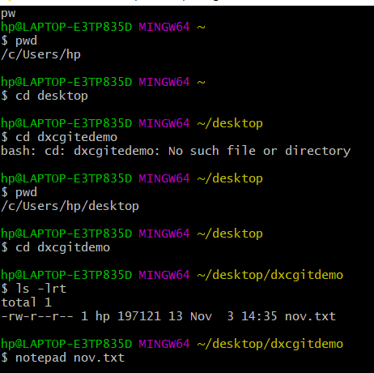

1. Git init: - To create a new Git repository.
2. Git status: -I is used to display the state of the repository and staging area
3. Git add nov.txt: -git add [filename] selects that file, and moves it to the staging area, marking it for inclusion in the next commit.
4. Git commit -a -m “file modified” : - this is used to modified the file
5. Git log:- Git log is a utility tool to review and read a history of everything that happens to a repository.

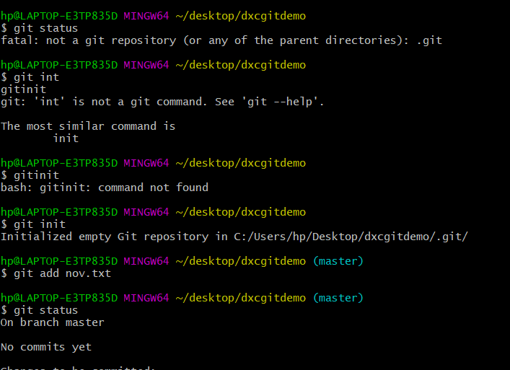

We

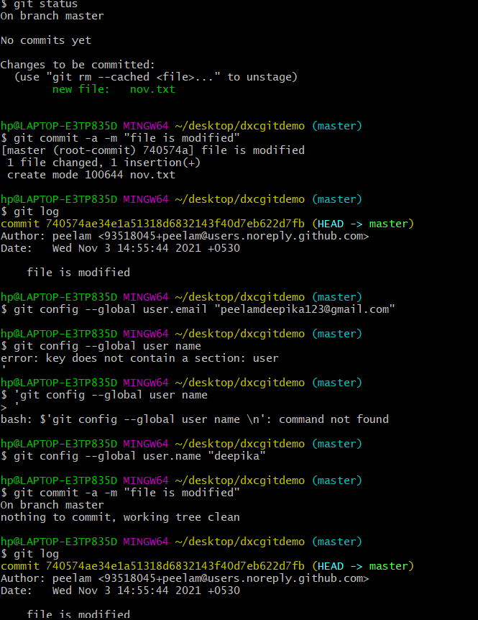

**Question -4**

Explain fork and cloning with screenshots

**Answer: -**

**Fork: -**

 A GitHub fork is a copy of a repository (repo) that sits in your account rather than the account from which you forked the data from. Once you have forked a repo, you own your forked copy.

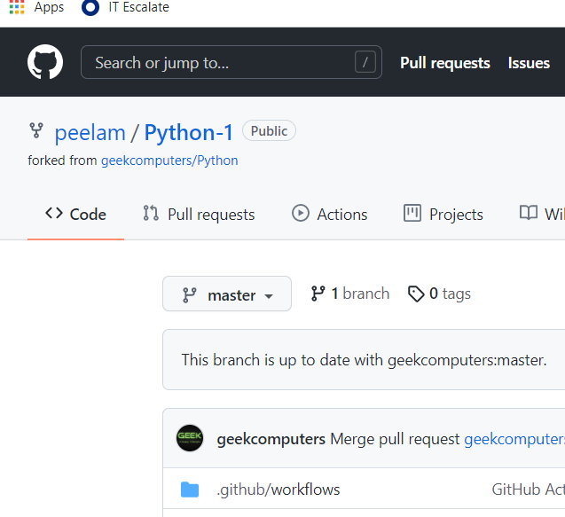

Cloning: - git clone is primarily used to point to an existing repo and make a clone or copy of that repo at in a new directory, at another location.

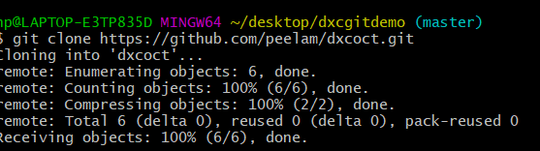

This is the command we used for cloning.

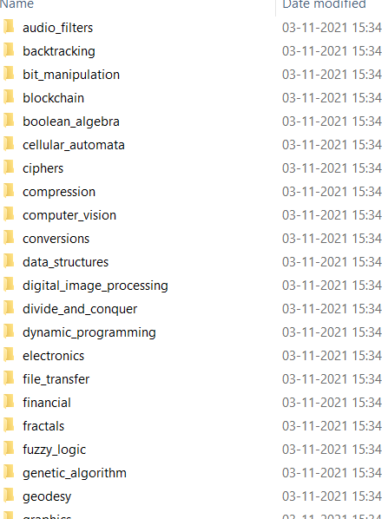

These are the files getting nov file after doing cloning.